**RAMNIRANJAN JHUNJHUNWALA COLLEGE**

**Department of Information Technology**

**Ghatkopar (West), Mumbai - 86**



**2021-2022**

**Seminar Report**

**on**

**NFT and It’s Marketplaces in Blockchain**

**In partial fulfillment of M.Sc. (INFORMATION TECHNOLOGY)**

**By**

**ShubhamKumar Shyambihari Yadav**

**Project Guide**

**Prof. Bharati Bhole**

**Topic :- NFT and It’s Marketplaces in Blockchain**

**What is Blockchain?**

Blockchain, sometimes referred to as Distributed Ledger Technology (DLT), makes the history of any digital asset unalterable and transparent through the use of decentralization and cryptographic hashing.

The [blockchain](https://www.guru99.com/blockchain-testing.html) is used for the secure transfer of items like money, property, contracts, etc, without requiring a third-party intermediary like a bank or government. Once data is recorded inside a blockchain, it is very difficult to change it.

**Blockchain** can be defined as a chain of blocks that contains information. The technique is intended to timestamp digital documents so that it’s not possible to backdate them or temper them. The purpose of blockchain is to solve the double records problem without the need for a central server.

**What Is an NFT?**

An Non-fungible tokens (NFTs) is a digital asset that represents real-world objects like art, music, in-game items and videos. They are bought and sold online, frequently with [cryptocurrency](https://www.forbes.com/advisor/investing/what-is-cryptocurrency/), and they are generally encoded with the same underlying software as many cryptos.

A non-fungible token (NFT) is a non-interchangeable unit of data stored on a blockchain, a form of digital ledger, that can be sold and traded.

For instance, famous digital artist Mike Winklemann, better known as “Beeple” crafted a composite of 5,000 daily drawings to create perhaps the most famous NFT of the moment, “EVERYDAYS: The First 5000 Days,” which sold at Christie’s for a [record-breaking $69.3 million](https://decrypt.co/60971/beeples-nft-artwork-sells-for-60-3-million-in-christies-auction). Anyone can view the individual images—or even the entire collage of images online for free. So why are people willing to spend millions on something they could easily screenshot or download? Because an NFT allows the buyer to own the original item. Not only that, it contains built-in authentication, which serves as proof of ownership. Collectors value those “digital bragging rights” almost more than the item itself.

**A bit of history**

The concept of non-fungible tokens has been around since 2012 when the colored coins created on the Bitcoin network were first introduced. However, NFTs managed to gain momentum back in 2017 with the emergence of Ethereum-based [CryptoPunks](https://www.larvalabs.com/cryptopunks), followed by [CryptoKitties](https://www.cryptokitties.co/) — a website that enables cryptocurrency users to buy and “breed” a limited edition of cute digital cats. These were considered the most successful and ground-breaking NFT projects for a long time, but as NFTs are progressing and being embraced by a wider range of illustrators as well as video and graphics artists, it’s pretty clear that we’ve yet to see even more jaw-dropping and extraordinary results.

**Examples of the most interesting use cases of NFT**

### **Digital art**

Professional artists have gained the opportunity to generate considerable profits from their works. It’s important to note that thanks to NFTs, talented amateur artists who used to simply publish their works on Instagram and Twitter, have also been able to reach the top and start making money from their work. So it’s possible for anyone with some artistic skill to benefit immensely from art NFTs.

### **Sports**

Fantasy sports have also taken advantage of NFT token sales. Sorare, a platform for creating and trading football non-fungible tokens, has already made several deals to create digital playing cards for Japan’s J League and Korea’s K League, as well as some top European clubs such as Bayern Munich, Paris Saint-Germain, and Juventus. The number of Sorare cards is limited, and each of them is verified via the Ethereum blockchain. The cards’ prices can be jaw-dropping, with the [Cristiano Ronaldo](https://sorare.com/cards/cristiano-ronaldo-dos-santos-aveiro-2020-unique-1/) card selling for $102,000. On top of this, it was reported in December 2020 that FC Barcelona defender [Gerard Piqué](https://www.forbes.com/sites/henryflynn/2020/12/18/gerard-pique-joins-sorare-to-help-reinvent-fantasy-soccer-worldwide/) was going to invest $4.3 million in Sorare and join the firm as a strategic adviser.

### **Gaming**

[Axel Infinity](https://axieinfinity.com/) is a website that specializes in selling cartoon characters for fighting, just like Po kemon, and is considered one of the most successful and popular crypto-collectible platforms. Among other NFT collectibles that are based on arcade games is [Street Fighter](https://www.streetfighter.cards/), which managed to generate about $1.5 million only weeks after the site was created.

**NFT blockchain options**

* 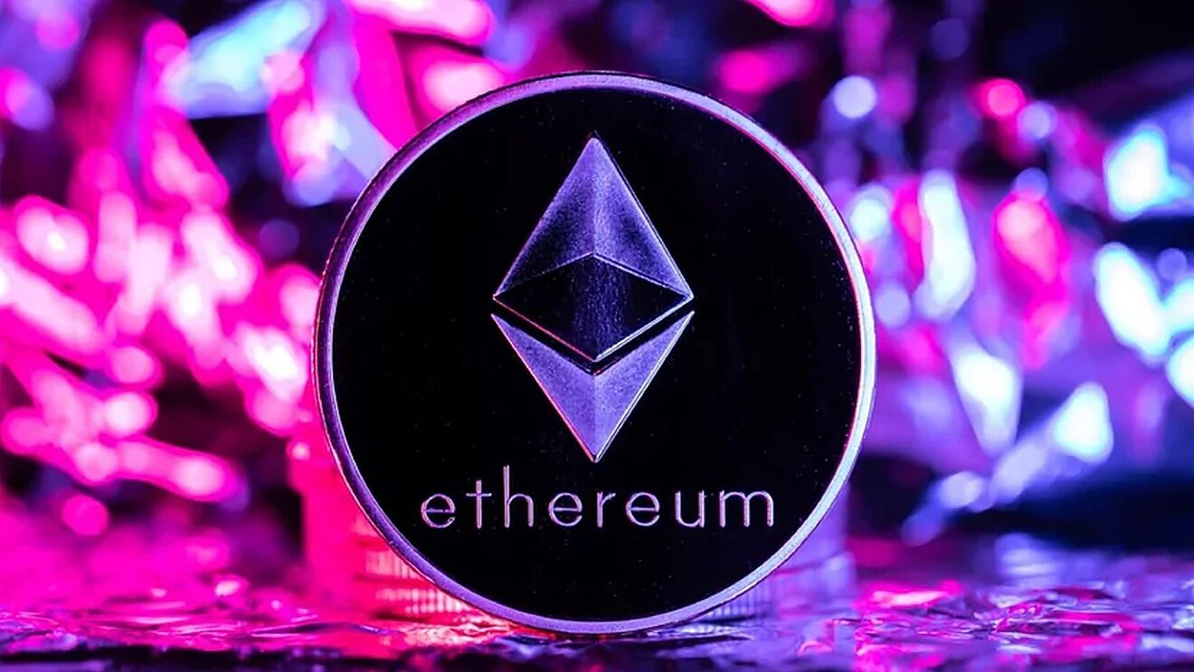Ethereum is by far the most popular system for buying, selling and creating unique, digital items. There is, however, a growing list of competitors that have also entered the market, including the following:
* Binance Smart Chain
* Flow (by Dapper Labs)
* Tron
* [EOS](https://www.coindesk.com/tech/2021/07/12/nft-marketplaces-a-beginners-guide/)
* Solana
* Hedera Hashgraph

**Common Features of NFTs are as below:**

* **Unique**– Each NFT has a unique property usually stored in tokens metadata. NFTs are unique in their character, and no two NFTs are the same. On the contrary, an original image .jpg file is the same as its copy, a .jpg file.
* **Digitally Scarce resource**– NFT is stored in the blockchain network. Hence, the certificate of ownership is available on multiple networks, making it possible to prove digital asset’s ownership.
* **Indivisible** – Most NFTs cannot be split into smaller denominations; you cannot buy or transfer a fraction of NFTs.
* **Ownership**– These tokens **guarantee the ownership** of the asset transferred.
* **Transparency-** Thanks to the decentralized and immutable nature of public distributed ledgers where all records of token issuance and other activities can be verified, buyers can be confident about the authenticity of a particular non-fungible token.
* **Fraud proof**– They are easily **transferable and fraud-proof.**

**The Advantages of NFTs**

1. **Decentralized marketplace**

NFTs allow creators to make money directly from their work. A great example is art, where someone would require an agent to sell and market their work. NFTs eliminate these middlemen and allow the artists or the original creators to interact and transact directly with their customers. This model further benefits the creators by allowing them to earn a commission each time the NFT exchanges hands.

**2.Unique**

They are rare in that only one of them can exist and can’t be easily forged.

**3. Collectibles**

Technically all NFTs are collectibles. As mentioned above, they are unique and only one of each can exist. Upon buying them, you can hold on to them and their value will increase over time.

**5. Immutable**

The metadata on the token can never be altered by anyone. Also, it can neither get erased, misplaced nor be removed from the blockchain.

**6. Copyright**

Perhaps one of the greatest advantages of the NFT technology is that it allows artists and content creators to retain their full copyright.

**7. Security**

When it comes to NFTs, you can be assured of security. The blockchains are decentralized in nature, which means that the data they hold is hosted in different nodes around the globe. There is always an identical record of the database at each of the nodes. Even when the network is down, there is always going to be a record of it somewhere.

## ****What is an NFT marketplace?****

NFT marketplace is a decentralized platform for purchasing, selling, and exchanging non-fungible tokens that represent various items for trading without any difficulty. NFT marketplaces generally support credit/debit cards and crypto transactions for selling and buying Non-Fungible tokens. The NFT marketplace also facilitates an auction for the assets stored on the marketplace.

In this platform, people have the opportunity to turn their collectible into an NFT. Then, they will put it up for sale by setting a predetermined price or starting an auction. After setting up, different bidders from various nations will participate in the auction and acquire NFTs. The marketplace is created on a blockchain network. Hence, the ownership of the NFTs that are acquired can be traced back to their original owners. The demand for NFT marketplaces is surging as NFTs are becoming more purposeful in the real world. Multiverse NFTs, Gaming NFTs, music NFTs are transforming the major industries’ unprecedently, further triggering the need for new features in NFT marketplaces. Today, worldwide crypto investors are earning hefty profits either by trading through NFT marketplaces or launching their NFT marketplaces for other users.

NFT marketplaces are platforms where NFTs can be stored, displayed, traded and in some cases minted (created).

In order to access and use these types of marketplaces, you will need to have the following:

**A crypto wallet :-**

You’ll need to choose a wallet that is compatible with the blockchain network that supports the NFTs you wish to buy (below). For example, if you plan to buy or sell NFTs based on the Ethereum blockchain platform, you will need to use a compatible Ethereum wallet such as MetaMask. For NFTs sold on the Solana platform, you will need to use a wallet service such as Sollet.

**An amount of coins in the wallet** :-

You will need to pre-fund your wallet before buying, listing or minting an NFT. Again, you will need to find out which cryptocurrencies are supported by the marketplace you intend to use.

**A user account :-**

You will need to set up an account on the particular marketplace you wish to purchase NFTs from.

## What are the salient features of an NFT marketplace?

There are multiple NFT marketplaces for music, artwork, memes, real estate, games, etc. Each marketplace needs a blockchain platform to function on, which powers the marketplace with all suitable features. The use of a particular blockchain while developing an NFT marketplace can add special features like interoperable NFTs, to the functioning of the marketplaces. All NFT marketplaces have some salient features that bring out their trading efficiency. Below mentioned are these salient features:

* **Storefront**The NFT marketplace has a dashboard called Storefront. The Storefront contains all of the information and description of the digital assets, such as the preview bid, information about the owner, and pricing values.
* **Filters**  
  The NFT marketplace has a filter function that simplifies the browsing experience for users. The filter tool allows users to narrow their search by price range, kind of digital asset, and listing procedure.
* **Auctions and purchasing**The NFT marketplace has an auction site that allows users to participate in a seamless bidding procedure. The auction webpage includes an expiration date for the bid, giving users additional incentive to begin the bidding process.
* **Digital wallet**The NFT marketplace, like the Binance decentralized exchange platform, includes an in-built digital wallet. Users can store and transfer cryptocurrencies using digital wallets.

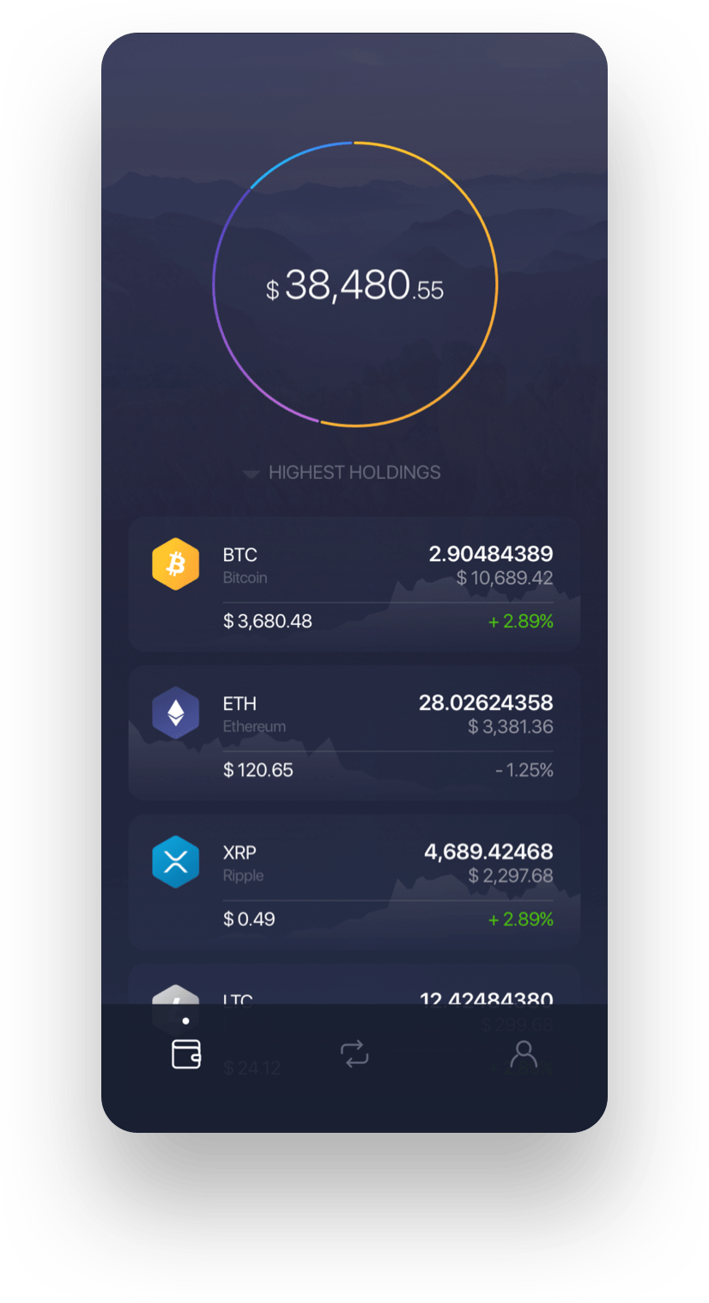

### **Popular NFT Marketplaces**

Once you’ve got your wallet set up and funded, there’s no shortage of NFT sites to shop.These marketplaces are to NFTs what Amazon or eBay are to goods. Currently, the largest NFT marketplaces are:

**•**[**OpenSea.io**](https://opensea.io/):-

This peer-to-peer platform bills itself a purveyor of “rare digital items and collectibles.” To get started, all you need to do is create an account to browse NFT collections.

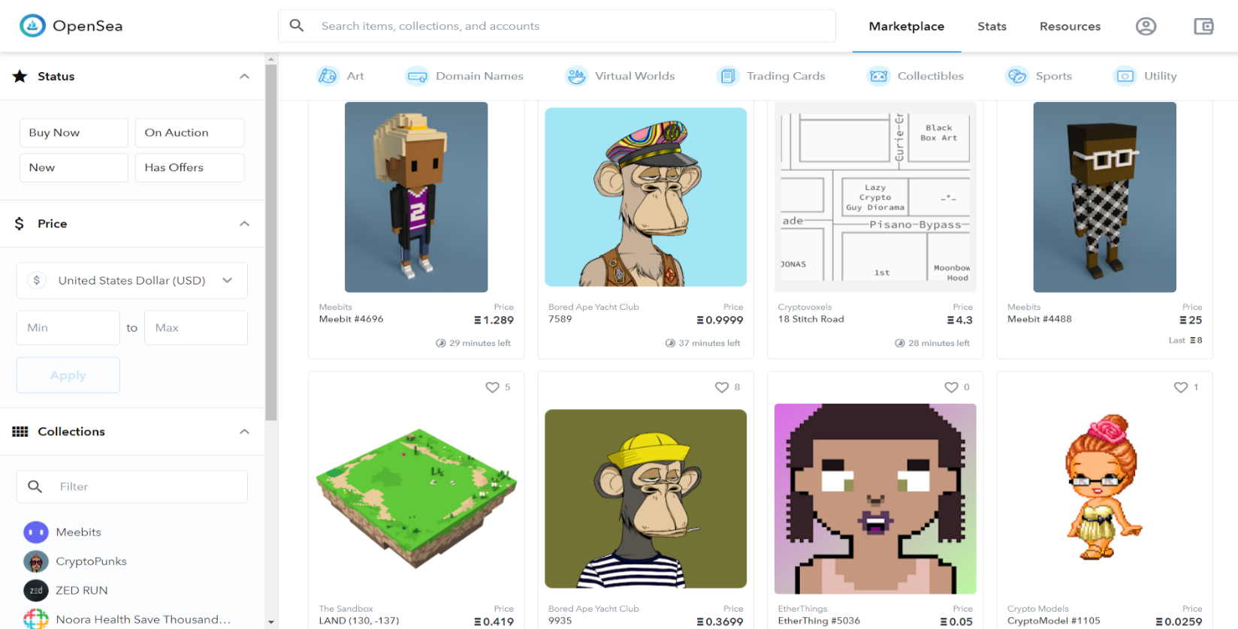

**•**[**Rarible**](https://rarible.com/):-

Similar to OpenSea, Rarible is a democratic, open marketplace that allows artists and creators to issue and sell NFTs. RARI tokens issued on the platform enable holders to weigh in on features like fees and community rules.

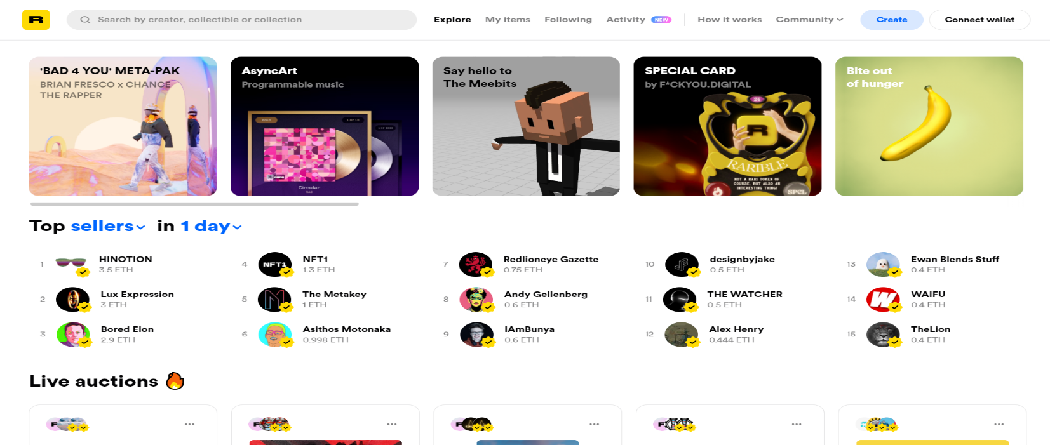

**•**[**Foundation**](https://foundation.app/): -

Here, artists must receive “upvotes” or an invitation from fellow creators to post their art. The community’s exclusivity and cost of entry—artists must also purchase “gas” to mint NFTs—means it may boast higher-caliber artwork. For instance, Nyan Cat creator Chris Torres sold the NFT on the Foundation platform. It may also mean higher prices — not necessarily a bad thing for artists and collectors seeking to capitalize, assuming the demand for NFTs remains at current levels, or even increases over time.

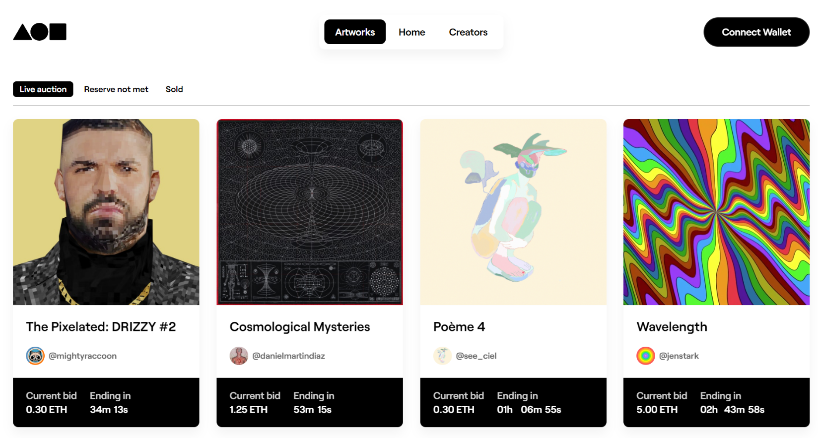

## How do these marketplaces work?

### **Signing up**

Signing up to an NFT marketplace can differ slightly from site to site, but the main steps to follow involve creating an account or connecting a supported digital wallet, or doing both. The button for this is typically located in the top right-hand corner of the NFT marketplace homepage. When connecting your wallet, you will be asked to enter your wallet password to complete the process.

### **Buying an NFT**

NFTs are usually purchased directly for a fixed price or through an auction. In some cases, prospective buyers can submit offers to the owner and attempt to negotiate a better price.

### **Selling an NFT**

Selling unique digital assets can be a more technically complicated process than buying them, particularly if the user is attempting to sell something they have created themselves (artwork, a soundtrack, a tweet, etc.).

* You will need to upload the chosen digital asset onto the marketplace and enter a fixed price or opt to sell the NFT via an auction.
* Next, the platform will verify the asset. If approved, it will be listed for sale.
* When the seller accepts a bid, the marketplace conducts the transfer from buyer to seller.

### **Minting an NFT**

If you want to create an NFT, you may consider starting with Ethereum, because it’s the largest system for these types of assets. You will need to have an Ethereum wallet that supports [ERC-721](https://github.com/ethereum/EIPs/issues/721) (Ethereum’s token standard for NFTs), such as MetaMask, Trust Wallet or Coinbase Wallet. Also, you will have to top up your wallet with about $50-$100 worth of [ether](https://www.coindesk.com/tech/2021/07/12/nft-marketplaces-a-beginners-guide/) to cover transaction fees (depending on how [congested](https://www.coindesk.com/tech/2021/07/12/nft-marketplaces-a-beginners-guide/) the network is). Most platforms have a “Create” button in the top right corner that will take you to the page where you can begin minting your NFTs.

**The First Custom NFT Marketplace: A Creaticles**

[Creaticles](https://creaticles.medium.com/)’ NFT Marketplace is the first of its kind.[Creaticles](https://creaticles.com/) is the blockchain industry’s first custom NFT request platform that connects businesses and individuals with creators. Any enthusiast with an idea can request custom NFTs, and the artists who bring those ideas to life get to build their reputation and earn rewards via cryptocurrencies. Users can engage in various contest modes to ensure their requests for NFTs — such as memes, logos, games, and web assets — are minted as requested.

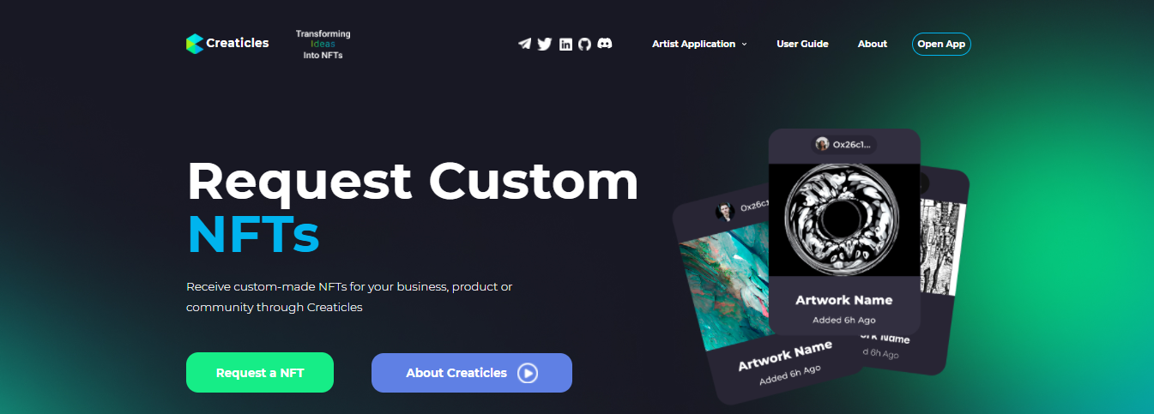

# **Overview**

With the end goal of connecting NFT collectors with digital artists, Creaticles asked our team to assist in the design, development, and launch of their NFT marketplace.

Since the NFT community consists of Web3 users and early adopters of decentralization, Creaticles selected Upstate Interactive based on our unique combination of UI/UX, Web3, and smart contract development experience.

# **Some Most Expensive NFTs Ever Sold**

## The Merge — $91.8M:-

## 

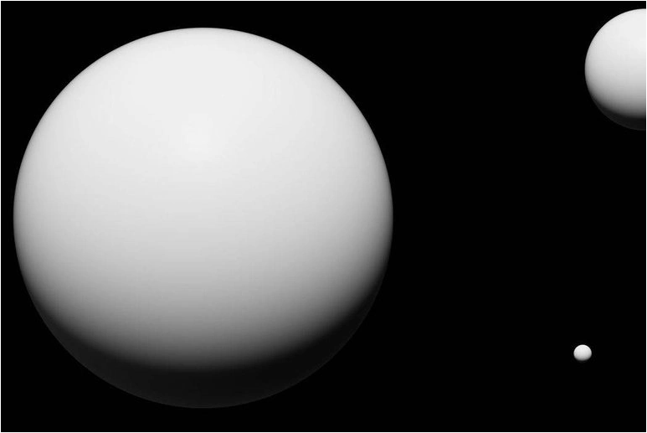

## The First 5000 Days – $69 M :-

## 

## Beeple, Human One — $29.98M:-

## 

## 

# **Vignesh Sundaresan buys NFT for $69 million; people can download it for free**

## Indian entrepreneur Vignesh Sundaresan had bought a non-fungible token (NFT) called Beeple for $69.3 million in an auction. An NFT is a digital asset that exists on a blockchain, a record of transactions kept on networked computers.

## 

## Conclusion

Non-fungible tokens are unique pieces of data that are stored on a blockchain. Digital art, music, video clips, tickets are a few examples of the digital assets that are being converted as NFTs. Some people think that this is a bubble that will burst and some people think that NFTs will drive the digital economy. The technology is still in the initial stages, so we have to wait and watch how it evolves.

**REFERENCES:-**

[**https://www.investopedia.com/**](https://www.investopedia.com/)

[**https://builtin.com/**](https://builtin.com/)

[**https://www.leewayhertz.com/**](https://www.leewayhertz.com/)

[**https://medium.com/**](https://medium.com/)

[**https://www.forbes.com/**](https://www.forbes.com/)

[**https://creaticles.com/**](https://creaticles.com/)

[**https://slideshare.net/**](https://slideshare.net/)

**Screenshots :-**

